10
Nonlinear Pharmacokinetics
In most cases, at therapeutic doses, the change in the amount of drug in the body or the change in its plasma concentration due to absorption, distribution, binding, metabolism or excretion, is proportional to its dose, whether administered as a single dose or as multiple doses. In such situations, the rate processes are said to follow first-order or linear kinetics and all semilog plots of C versus t for different doses, when corrected for dose administered, are superimposable. This is called as principle of superposition. The important pharmacokinetic parameters viz. F, Ka, KE, Vd, ClR and ClH which describe the time-course of a drug in the body remain unaffected by the dose i.e. the pharmacokinetics is dose-independent.
In some instances, the rate process of a drug’s ADME are dependent upon carrier or enzymes that are substrate-specific, have definite capacities, and susceptible to saturation at high drug concentration. In such cases, an essentially first-order kinetics transform into a mixture of first-order and zero-order rate processes and the pharmacokinetic parameters change with the size of the administered dose. The pharmacokinetics of such drugs are said to be dose-dependent. Other terms synonymous with it are mixed-order, nonlinear and capacity-limited kinetics. Drugs exhibiting such a kinetic profile are sources of variability in pharmacological response.
There are several tests to detect nonlinearity in pharmacokinetics but the simplest ones are –
- Determination of steady-state plasma concentration at different doses. If the steady-state concentrations are directly proportional to the dose, then linearity in the kinetics exists. Such proportionality is not observable when there is nonlinearity.
- Determination of some of the important pharmacokinetic parameters such as fraction bioavailable, elimination half-life or total systemic clearance at different doses of the drug. Any change in these parameters which are usually constant, is indicative of nonlinearity.
CAUSES OF NONLINEARITY
Nonlinearities can occur in drug absorption, distribution, metabolism and excretion.
Drug Absorption
Nonlinearity in drug absorption can arise from 3 important sources –
- When absorption is solubility or dissolution rate-limited e.g. griseofulvin. At higher doses, a saturated solution of the drug is formed in the GIT or at any other extravascular site and the rate of absorption attains a constant value.
- When absorption involves carrier-mediated transport systems e.g. absorption of riboflavin, ascorbic acid, cyanocobalamin, etc. Saturation of the transport system at higher doses of these vitamins results in nonlinearity.
- When presystemic gut wall or hepatic metabolism attains saturation e.g. propranolol, hydralazine and verapamil. Saturation of presystemic metabolism of these drugs at high doses leads to increased bioavailability.
The parameters affected will be F, Ka, Cmax and AUC. A decrease in these parameters is observed in the former two cases and an increase in the latter case. Other causes of nonlinearity in drug absorption are changes in gastric emptying and GI blood flow and other physiologic factors. Nonlinearity in drug absorption is of little consequence unless availability is drastically affected.
Drug Distribution
Nonlinearity in distribution of drugs administered at high doses may be due to –
- Saturation of binding sites on plasma proteins e.g. phenylbutazone and naproxen. There is a finite number of binding sites for a particular drug on plasma proteins and, theoretically, as the concentration is raised, so too is the fraction unbound.
- Saturation of tissue binding sites e.g. thiopental and fentanyl. With large single bolus doses or multiple dosing, saturation of tissue storage sites can occur.
In both cases, the free plasma drug concentration increases but Vd increases only in the former case whereas it decreases in the latter. Clearance is also altered depending upon the extraction ratio of the drug. Clearance of a drug with high ER is greatly increased due to saturation of binding sites. Unbound clearance of drugs with low ER is unaffected and one can expect an increase in pharmacological response.
Drug Metabolism
The nonlinear kinetics of most clinical importance is capacity-limited metabolism since small changes in dose administered can produce large variations in plasma concentration at steady-state. It is a major source of large intersubject variability in pharmacological response.
Two important causes of nonlinearity in metabolism are –
- Capacity-limited metabolism due to enzyme and/or cofactor saturation. Typical examples include phenytoin, alcohol, theophylline, etc.
- Enzyme induction e.g. carbamazepine, where a decrease in peak plasma concentration has been observed on repetitive administration over a period of time. Autoinduction characterized in this case is also dose-dependent. Thus, enzyme induction is a common cause of both dose- and time-dependent kinetics.
Saturation of enzyme results in decreased ClH and therefore increased Css. Reverse is true for enzyme induction. Other causes of nonlinearity in biotransformation include saturation of binding sites, inhibitory effect of the metabolite on enzyme and pathologic situations such as hepatotoxicity and changes in hepatic blood flow.
Drug Excretion
The two active processes in renal excretion of a drug that are saturable are –
- Active tubular secretion e.g. penicillin G. After saturation of the carrier system, a decrease in renal clearance occurs.
- Active tubular reabsorption e.g. water soluble vitamins and glucose. After saturation of the carrier system, an increase in renal clearance occurs.
Other sources of nonlinearity in renal excretion include forced diuresis, changes in urine pH, nephrotoxicity and saturation of binding sites.
Biliary secretion, which is also an active process, is also subject to saturation e.g. tetracycline and indomethacin.
MICHAELIS MENTEN EQUATION
The kinetics of capacity-limited or saturable processes is best described by Michaelis-Menten equation:
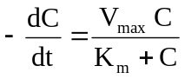 | (10.1)
Where, –dC/dt = rate of decline of drug concentration with time,
Vmax = theoretical maximum rate of the process, and
Km = Michaelis constant.
Three situations can now be considered depending upon the values of Km and C:
- When Km = C
Under this situation, the equation 10.1 reduces to:
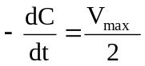 | (10.2)
i.e. the rate of process is equal to one-half its maximum rate (Fig. 10.1).
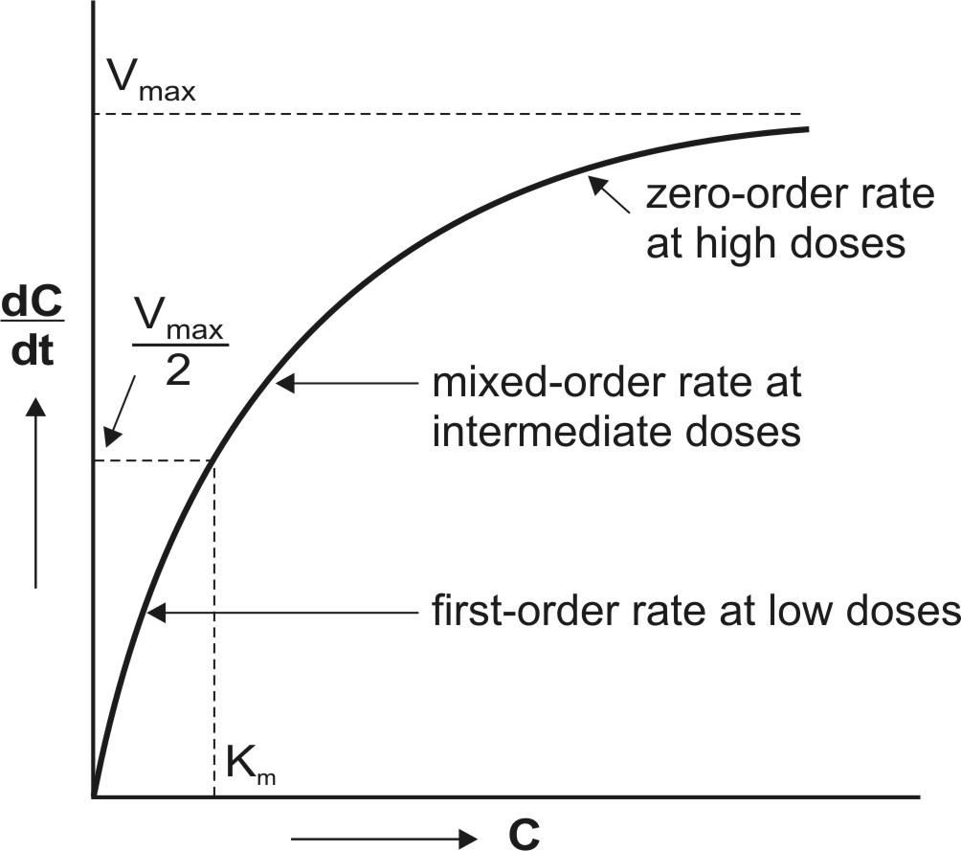
Fig. 10.1 A plot of Michaelis-Menten equation (elimination rate dC/dt versus concentration C). Initially, the rate increases linearly (first-order) with concentration, becomes mixed-order at higher concentration and then reaches maximum (Vmax) beyond which it proceeds at a constant rate (zero-order).
- When Km >> C
Here, Km + C ≡ Km and the equation 10.1 reduces to:
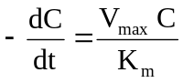 | (10.3)
The above equation is identical to the one that describes first-order elimination of a drug where Vmax/Km = KE. This means that the drug concentration in the body that results from usual dosage regimens of most drugs is well below the Km of the elimination process with certain exceptions such as phenytoin and alcohol.
- When Km << C
Under this condition, Km + C ≡ C and the equation 10.1 will become:
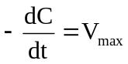 | (10.4)
The above equation is identical to the one that describes a zero-order process i.e. the rate process occurs at a constant rate Vmax and is independent of drug concentration e.g. metabolism of ethanol.
Estimation of Km and Vmax
The parameters of capacity-limited processes like metabolism, renal tubular secretion and biliary excretion can be easily defined by assuming one-compartment kinetics for the drug and that elimination involves only a single capacity-limited process.
The parameters Km and Vmax can be assessed from the plasma concentration-time data collected after i.v. bolus administration of a drug with nonlinear elimination characteristics.
Rewriting equation 10.1.
(10.1)
Integration of above equation followed by conversion to log base 10 yields:
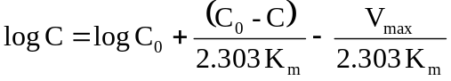 | (10.5)
A semilog plot of C versus t yields a curve with a terminal linear portion having slope –Vmax/2.303Km and when back extrapolated to time zero gives Y-intercept log 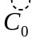(see Fig. 10.2). The equation that describes this line is:
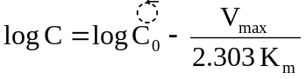 | (10.6)
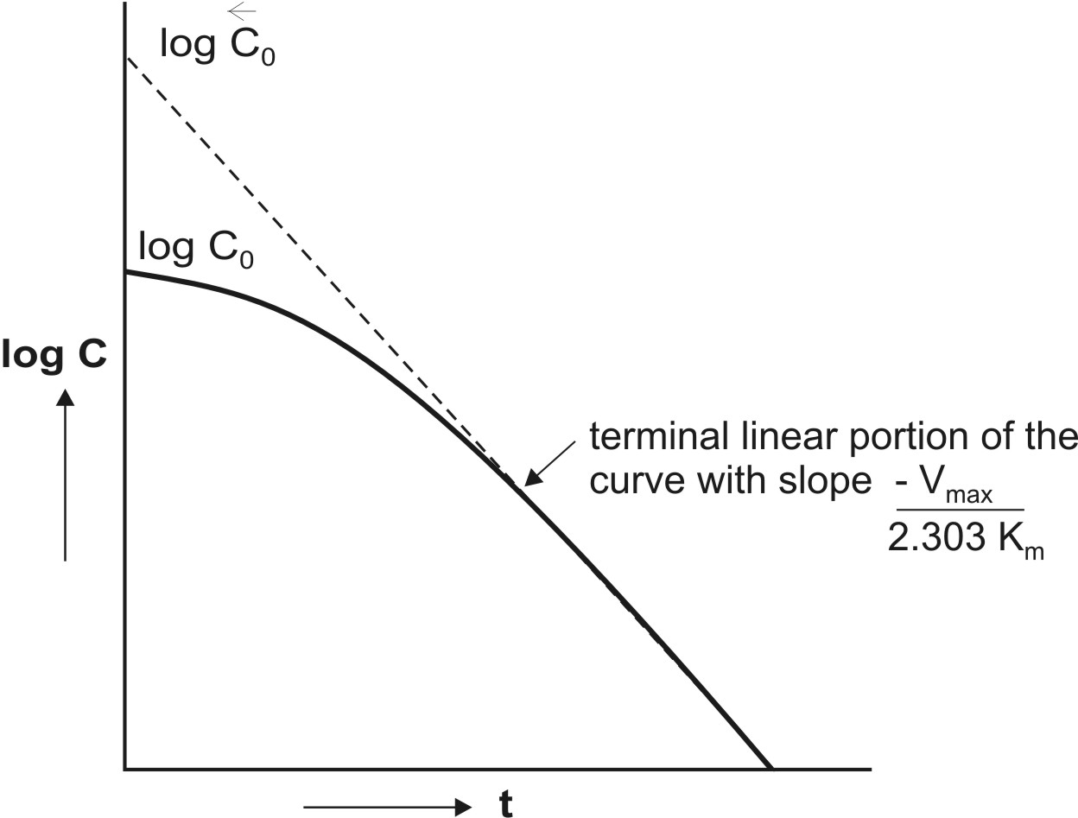
Fig. 10.2 Semilog plot of a drug given as i.v. bolus with nonlinear elimination and that fits one-compartment kinetics.
At low plasma concentrations, equations 10.5 and 10.6 are identical. Equating the two and simplifying further, we get:
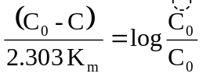 | (10.7)
Km can thus be obtained from above equation. Vmax can be computed by substituting the value of Km in the slope value.
An alternative approach of estimating Vmax and Km is determining the rate of change of plasma drug concentration at different times and using the reciprocal of the equation 10.1. Thus:
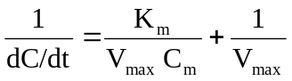 | (10.8)
where Cm = plasma concentration at midpoint of the sampling interval. A double reciprocal plot or the Lineweaver-Burke plot of 1/(dC/dt) versus 1/Cm of the above equation yields a straight line with slope = Km/Vmax and y-intercept = 1/Vmax.
A disadvantage of Lineweaver-Burke plot is that the points are clustered. More reliable plots in which the points are uniformly scattered are Hanes-Woolf plot (equation 10.9) and Woolf-Augustinsson-Hofstee plot (equation 10.10).
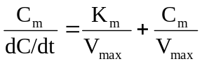 | (10.9)
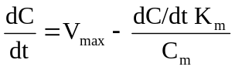 | (10.10)
The above equations are rearrangements of equation 10.8. Equation 10.9 is used to plot Cm/(dC/dt) versus Cm and equation 10.10 to plot dC/dt versus (dC/dt)/Cm. The parameters Km and Vmax can be computed from the slopes and y-intercepts of the two plots.
Km and Vmax from Steady-State Concentration
When a drug is administered as a constant rate i.v. infusion or in a multiple dose regimen, the steady-state concentration Css is given in terms of dosing rate DR as:
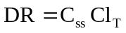 | (10.11)
where DR = Ro when the drug is administered as zero-order i.v. infusion and it is equal to FXo/τ when administered as multiple oral dosage regimen (F is fraction bioavailable, Xo is oral dose and τ is dosing interval).
At steady-state, the dosing rate equals rate of decline in plasma drug concentration and if the decline (elimination) is due to a single capacity-limited process (for e.g. metabolism), then;
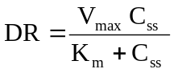 | (10.12)
A plot of Css versus DR yields a typical hockey-stick shaped curve as shown in Fig. 10.3.
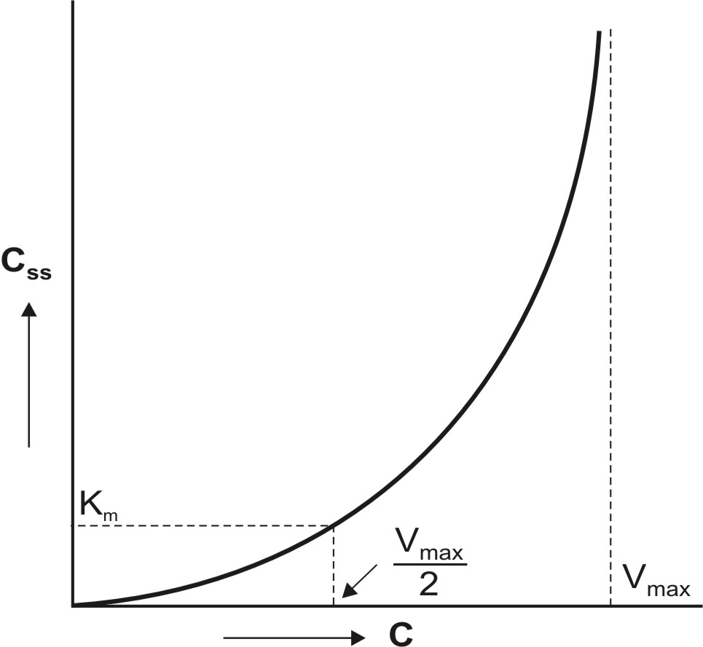
Fig. 10.3 Curve for a drug with nonlinear kinetics obtained by plotting the steady-state concentration versus dosing rates.
To define the characteristics of the curve with a reasonable degree of accuracy, several measurements must be made at steady-state during dosage with different doses.
Practically, one can graphically compute Km and Vmax in 3 ways:
- Lineweaver-Burke Plot/Klotz Plot
Taking reciprocal of equation 10.12, we get:
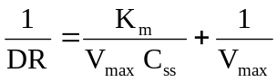 | (10.13)
Equation 10.13 is identical to equation 10.8 given earlier. A plot of 1/DR versus 1/Css yields a straight line with slope Km/Vmax and y-intercept 1/Vmax (see Fig. 10.4).
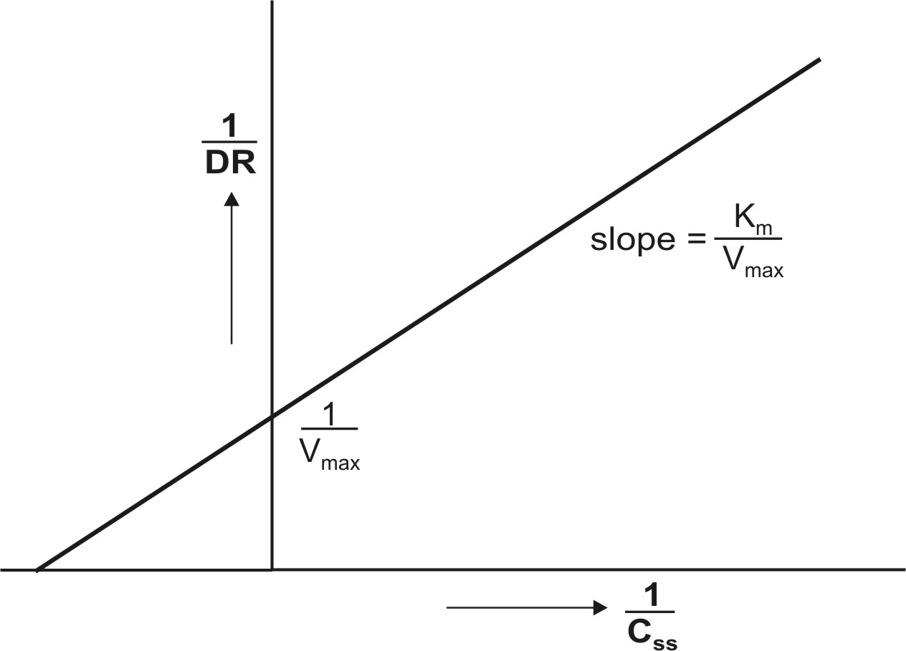
Fig. 10.4 Lineweaver-Burke/Klotz plot for estimation of Km and Vmax at steady-state concentration of drug.

- Direct Linear Plot
Here, the graph is considered as shown in Fig. 10.5. A pair of Css viz. Css,1 and Css,2 obtained with two different dosing rates DR1 and DR2 is plotted. The points Css,1 and DR1 are joined to form a line and a second line is obtained similarly by joining Css,2 and DR2. The point where these two lines intersect each other is extrapolated on DR axis to obtain Vmax and on x-axis to get Km.
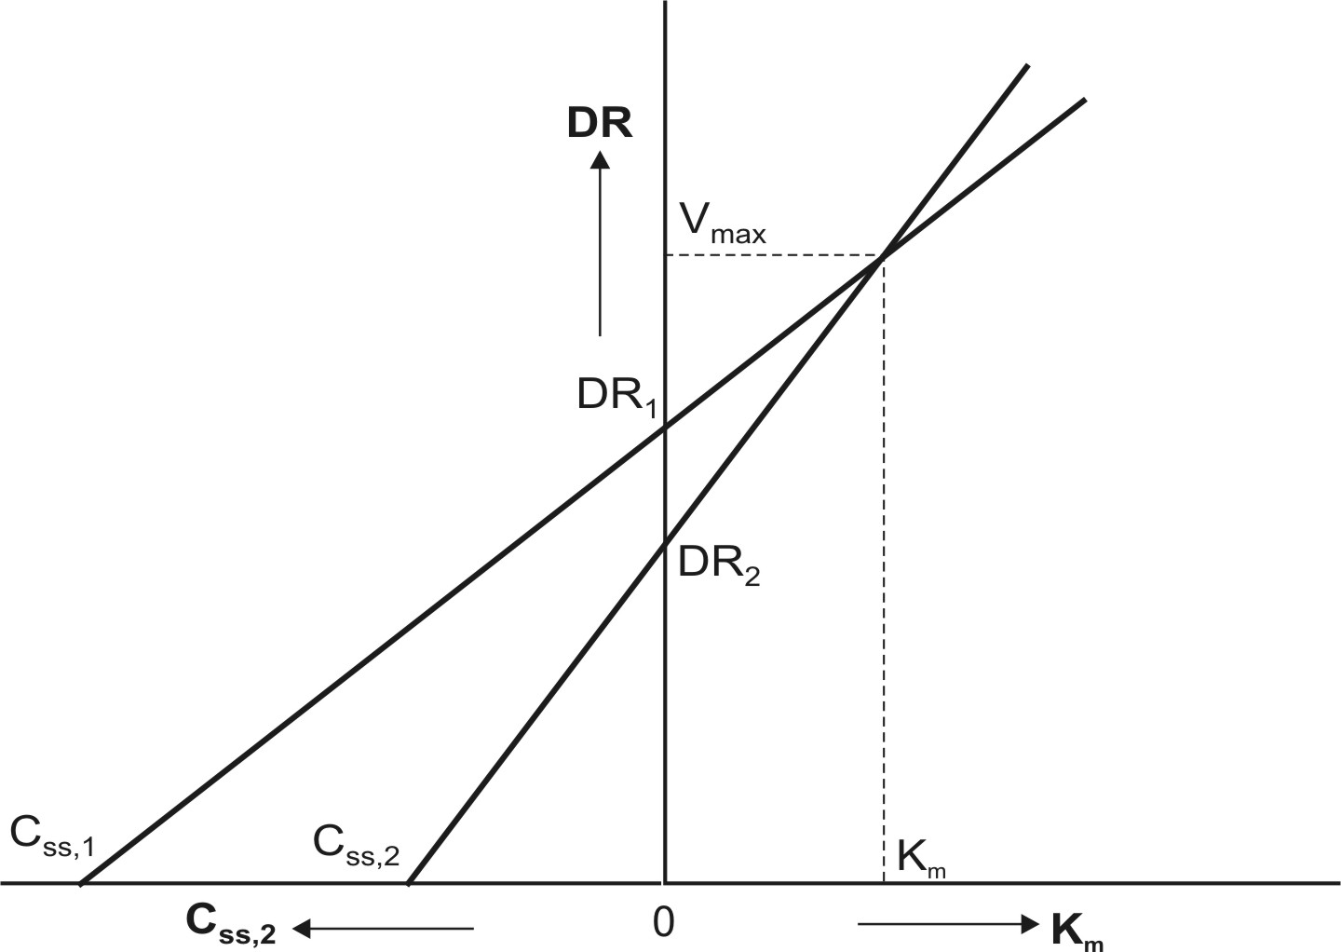
Fig. 10.5 Direct linear plot for estimation of Km and Vmax at steady-state concentrations of a drug given at different dosing rates.
3. The third graphical method of estimating Km and Vmax involves rearranging equation 10.12 to yield:
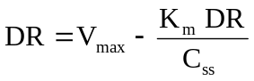 | (10.14)
A plot of DR versus DR/Css yields a straight line with slope -Km and Y-intercept Vmax.
Km and Vmax can also be calculated numerically by setting up simultaneous equations as shown below:
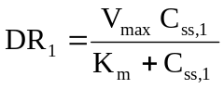 | (10.15)
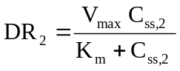 | (10.16)
Combination of the above two equations yields:
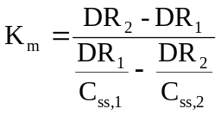 | (10.17)
After having computed Km, its subsequent substitution in any one of the two simultaneous equations will yield Vmax.
It has been observed that Km is much less variable than Vmax. Hence, if mean Km for a drug is known from an earlier study, then instead of two, a single measurement of Css at any given dosing rate is sufficient to compute Vmax.
There are several limitations of Km and Vmax estimated by assuming one-compartment system and a single capacity-limited process. More complex equations will result and the computed Km and Vmax will usually be larger when:
- The drug is eliminated by more than one capacity-limited process.
- The drug exhibits parallel capacity-limited and first-order elimination processes.
- The drug follows multicompartment kinetics.
However, Km and Vmax obtained under such circumstances have little practical applications in dosage calculations.
Drugs that behave nonlinearly within the therapeutic range (for example, phenytoin shows saturable metabolism) yield less predictable results in drug therapy and possess greater potential in precipitating toxic effects.
QUESTIONS
- Define dose-dependent kinetics. Quote simple tests by which it can be detected in a rate process.
- Why are drugs that show nonlinearity in pharmacokinetics considered sources of variability in pharmacological response?
- What processes of drug ADME are known to show nonlinearity? Give examples.
- When administered at high doses, how does the pharmacokinetic parameters — t½, Vd, Cmax, etc. change for drugs known to undergo capacity-limited elimination?
- What are the limitations in calculating Km and Vmax by assuming one-compartment model and a single capacity-limited process?
- Using the following data of a drug having Km of 0.2 mcg/ml and Vmax of 1.0 mcg/ml/hour, determine the concentrations at which the drug shows first-order, zero-order and mixed-order metabolic rates.
Concentration (mcg/ml) 0.02 0.2 20.0
Metabolic Rate (mcg/ml/H) 0.1 0.5 1.0
- Theophylline was administered to a patient at dosing rates of 600 mg/day and 1200 mg/day and the respective steady-state concentrations were found to be 9.8 mg/L and 28.6 mg/l. Find Km and Vmax. Determine the dosing rate to achieve a Css of 15 mg/l.
Answer : Km = 31.14 mg/l, Vmax = 2507 mg/day and DR = 815 mg/day.

